**Tuesday – Azure synapse Analytics (12 sep)**

Autoresolve Integration runtime 🡪 execution engine 🡪 reads the data from src and performs the transformation in compute nodes.

Compute nodes 🡪 virtual machine

Self hosted

ADF 🡪spark databricks notebook

Azure synapse analytics

Two engines to process data 🡪 sql, Apache spark – it is Poly glot (support multiple languages – scala, python, r, java, sql, c#)

Information is stored in ADLS gen2

Synapse 🡪 data lake storage + sql data warehouse + azure analytics

Synapse runtime is very fast.

Distributed computing 🡪

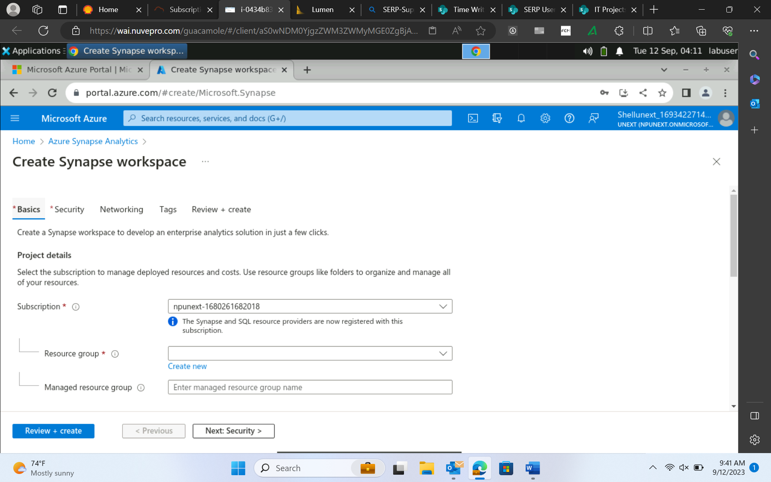

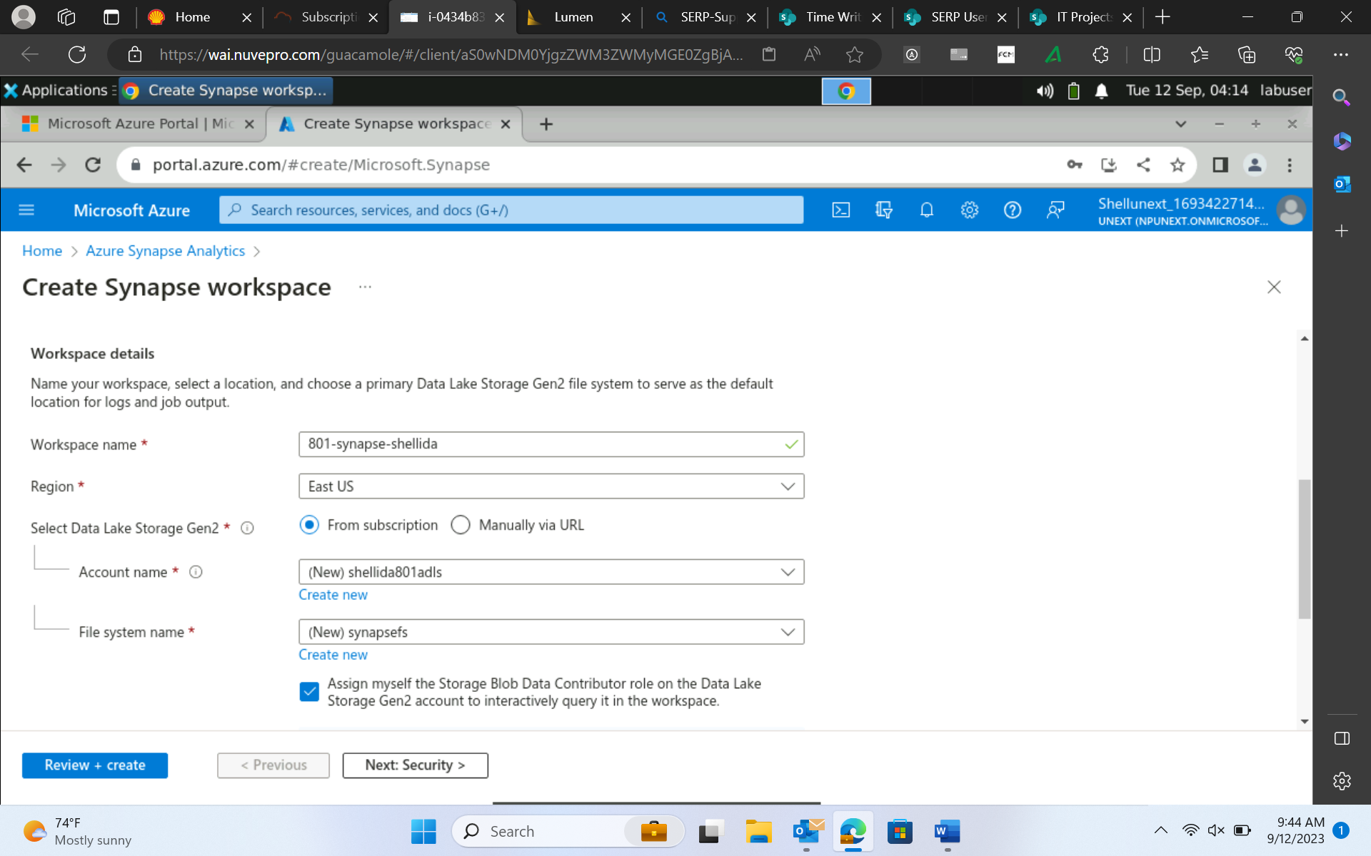

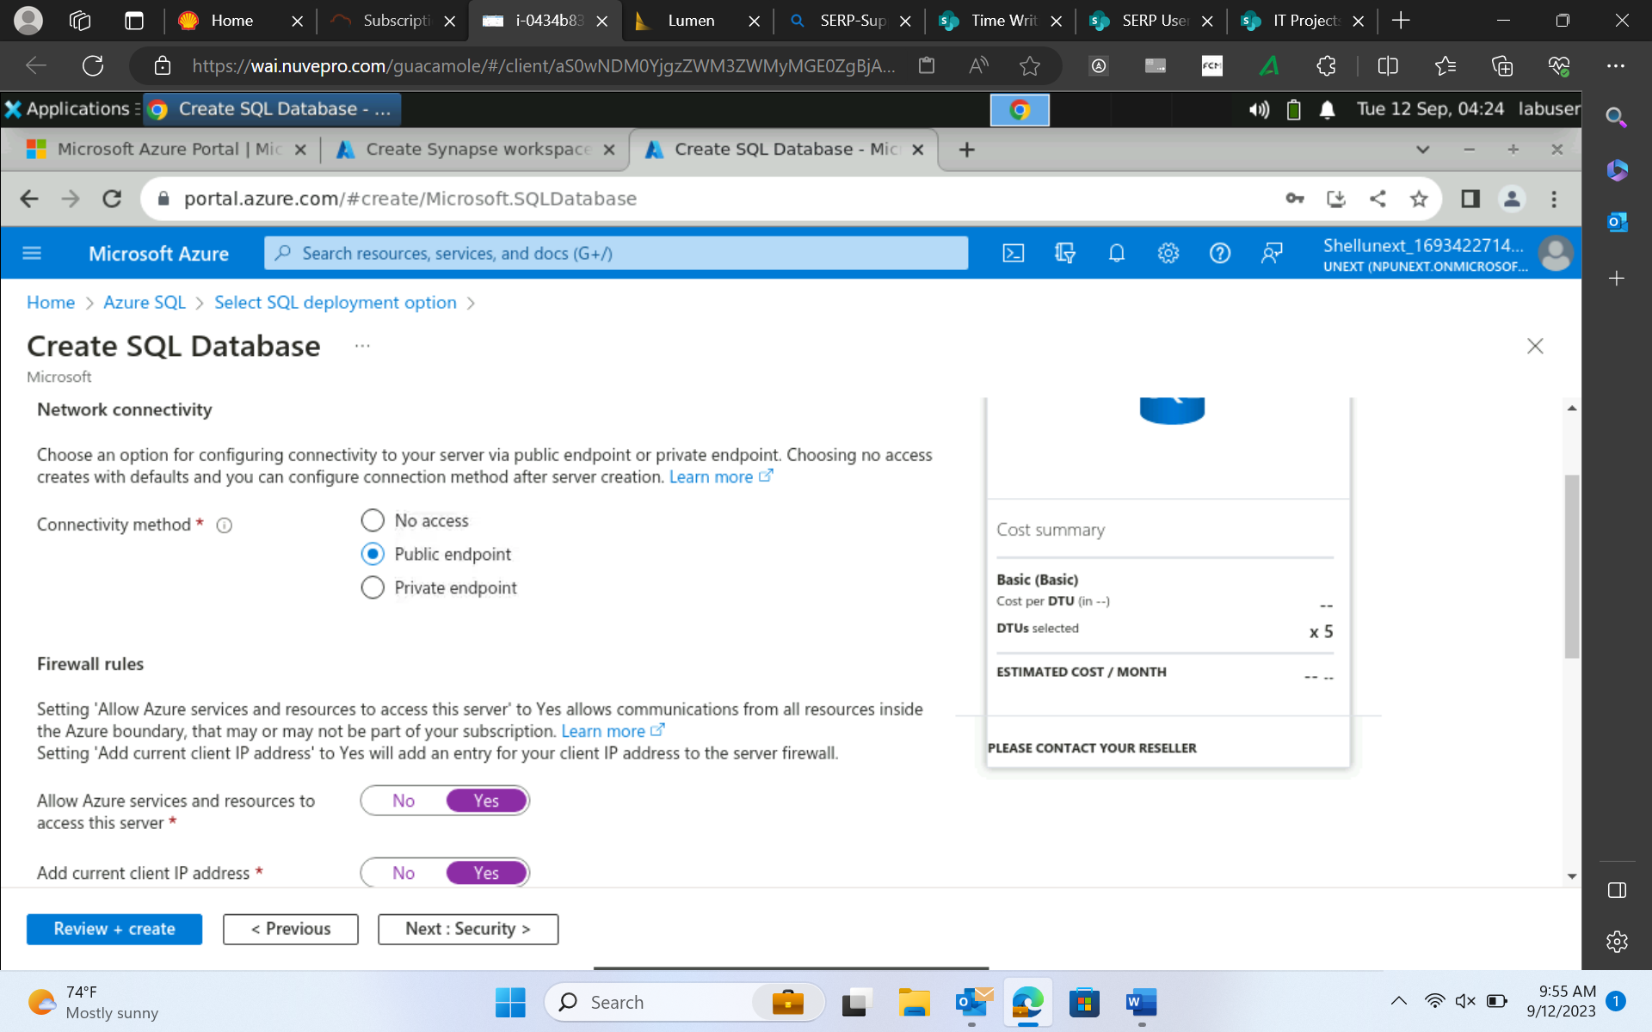

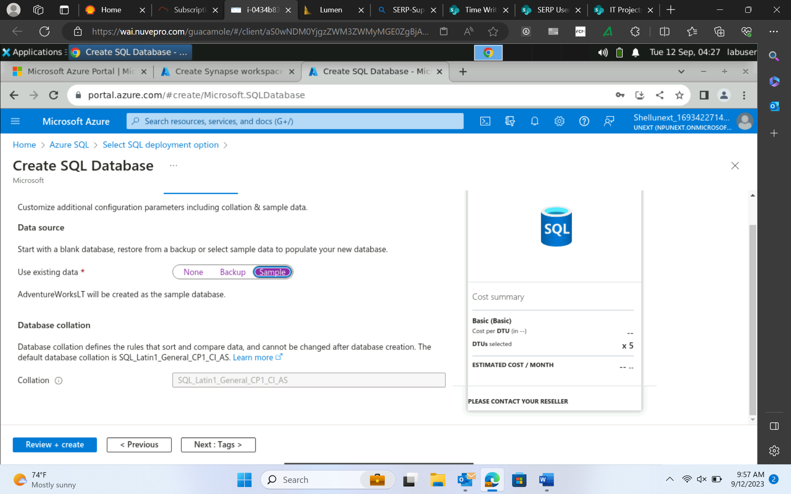

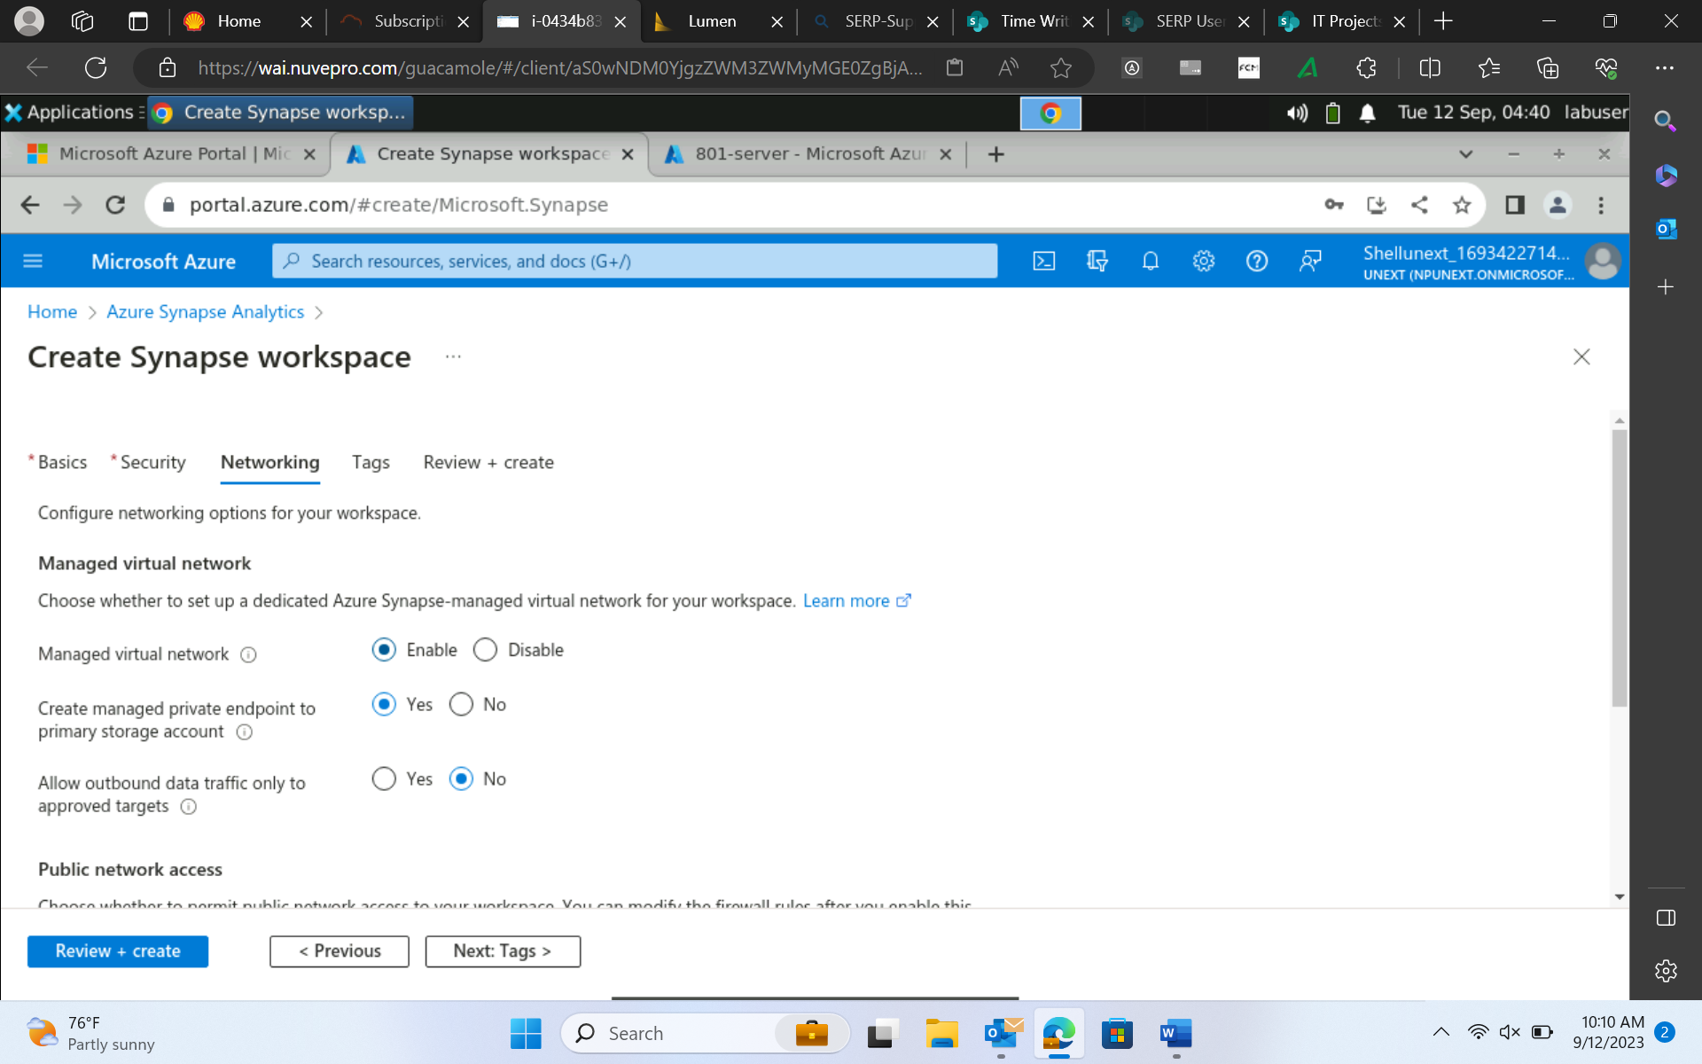

**Then open synapse studio**

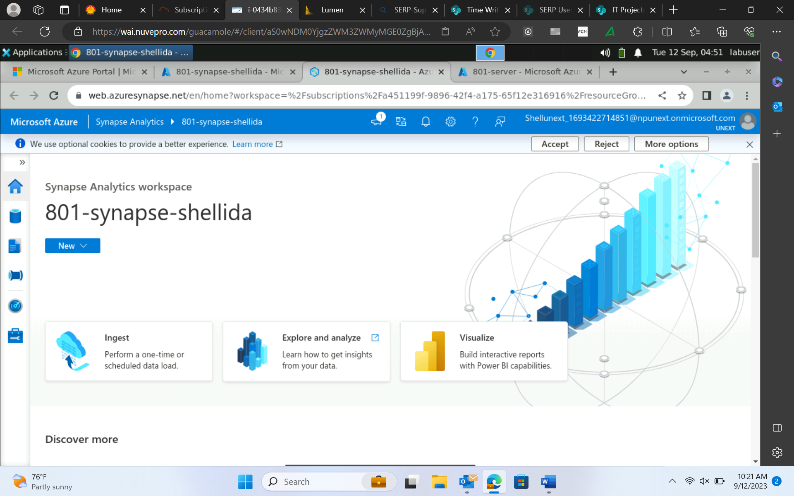

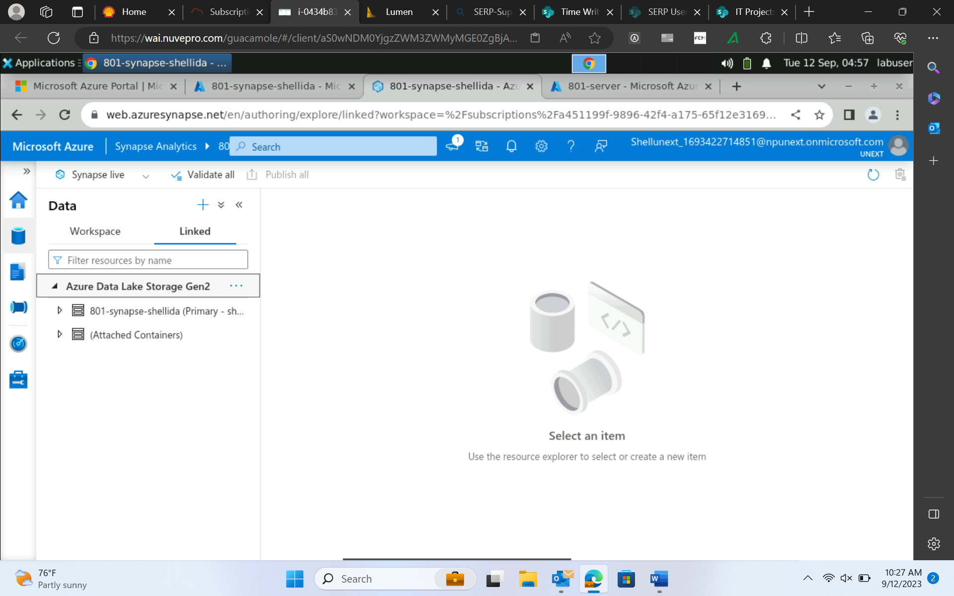

File format : csv, json, binary

ORC

**Parquet – most recommended 🡪 spark 🡪 column row format 🡪 contains metadata**

RCF

Avro

These are used for storage optimization. these are compression/encoded file formats

Parquet 🡺 on top can use **snappy** 🡪 more compressed

Azure synapse

Sql pool 🡪 1. Serverless(default)(builtin)🡪 auto pause 🡪 – immediately available for your workspace. 2. Dedicated sql pool. 🡪dedicated for your project/complex query/

Hash, Roundrobin, replicated

a

Architecture :

Traditional data storage+data processing : tightly coupled

Data engg:

**Master**(control node) **slaves**(compute node🡪 1000s compute node in a pool) **architecture**

**Compute and storage are decoupled 🡪 can run these services separately**

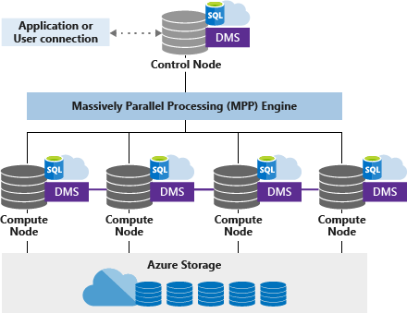

DMS – coordinates data movement between compute nodes.

Upload files in adls storage

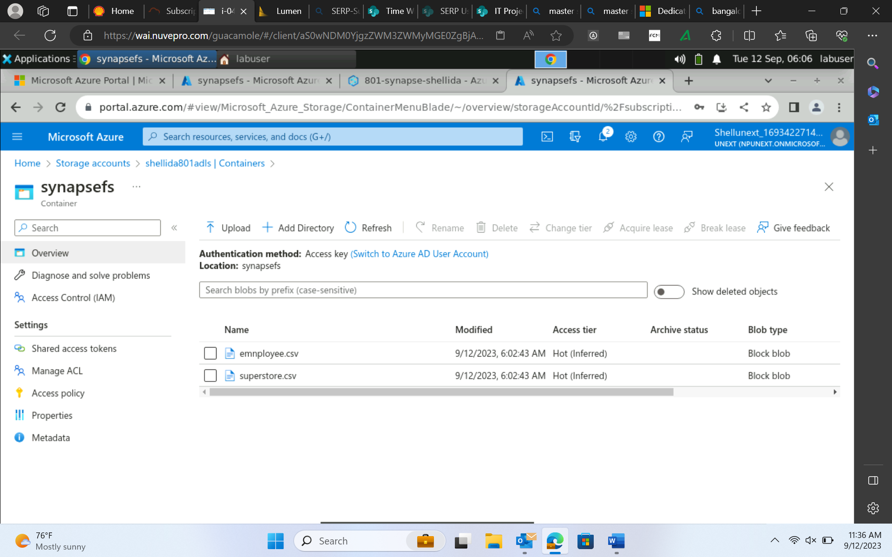

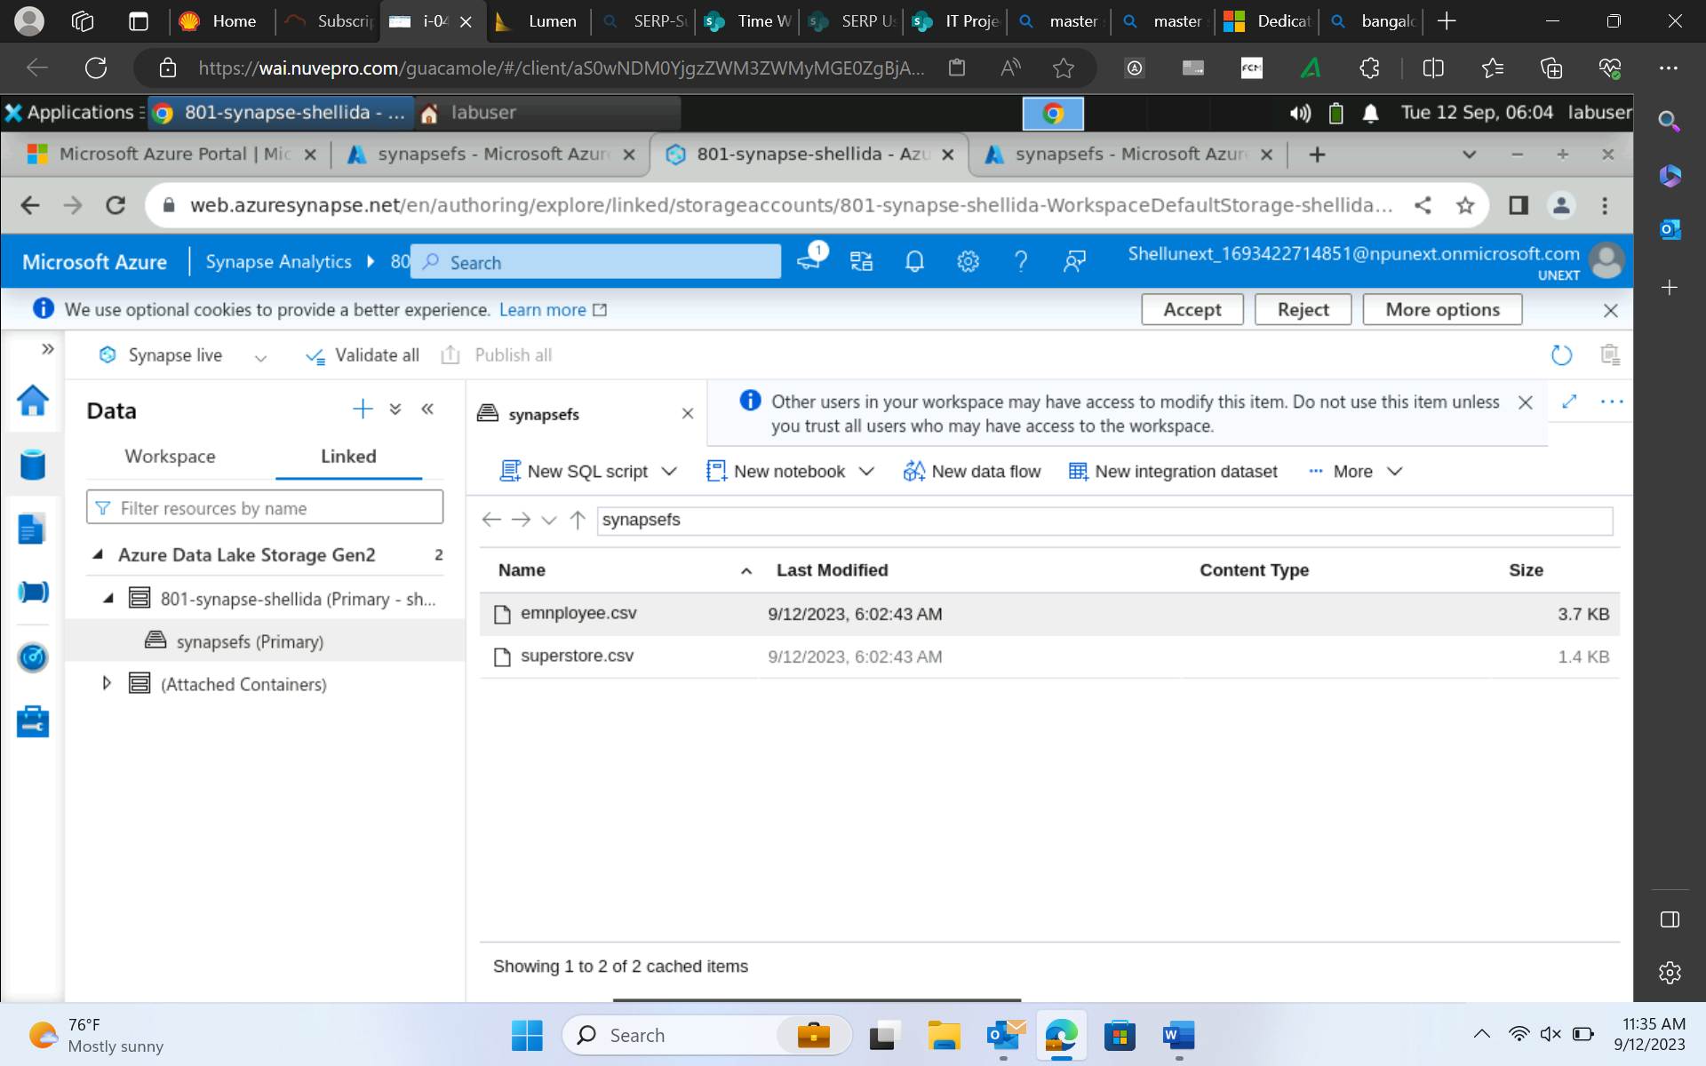

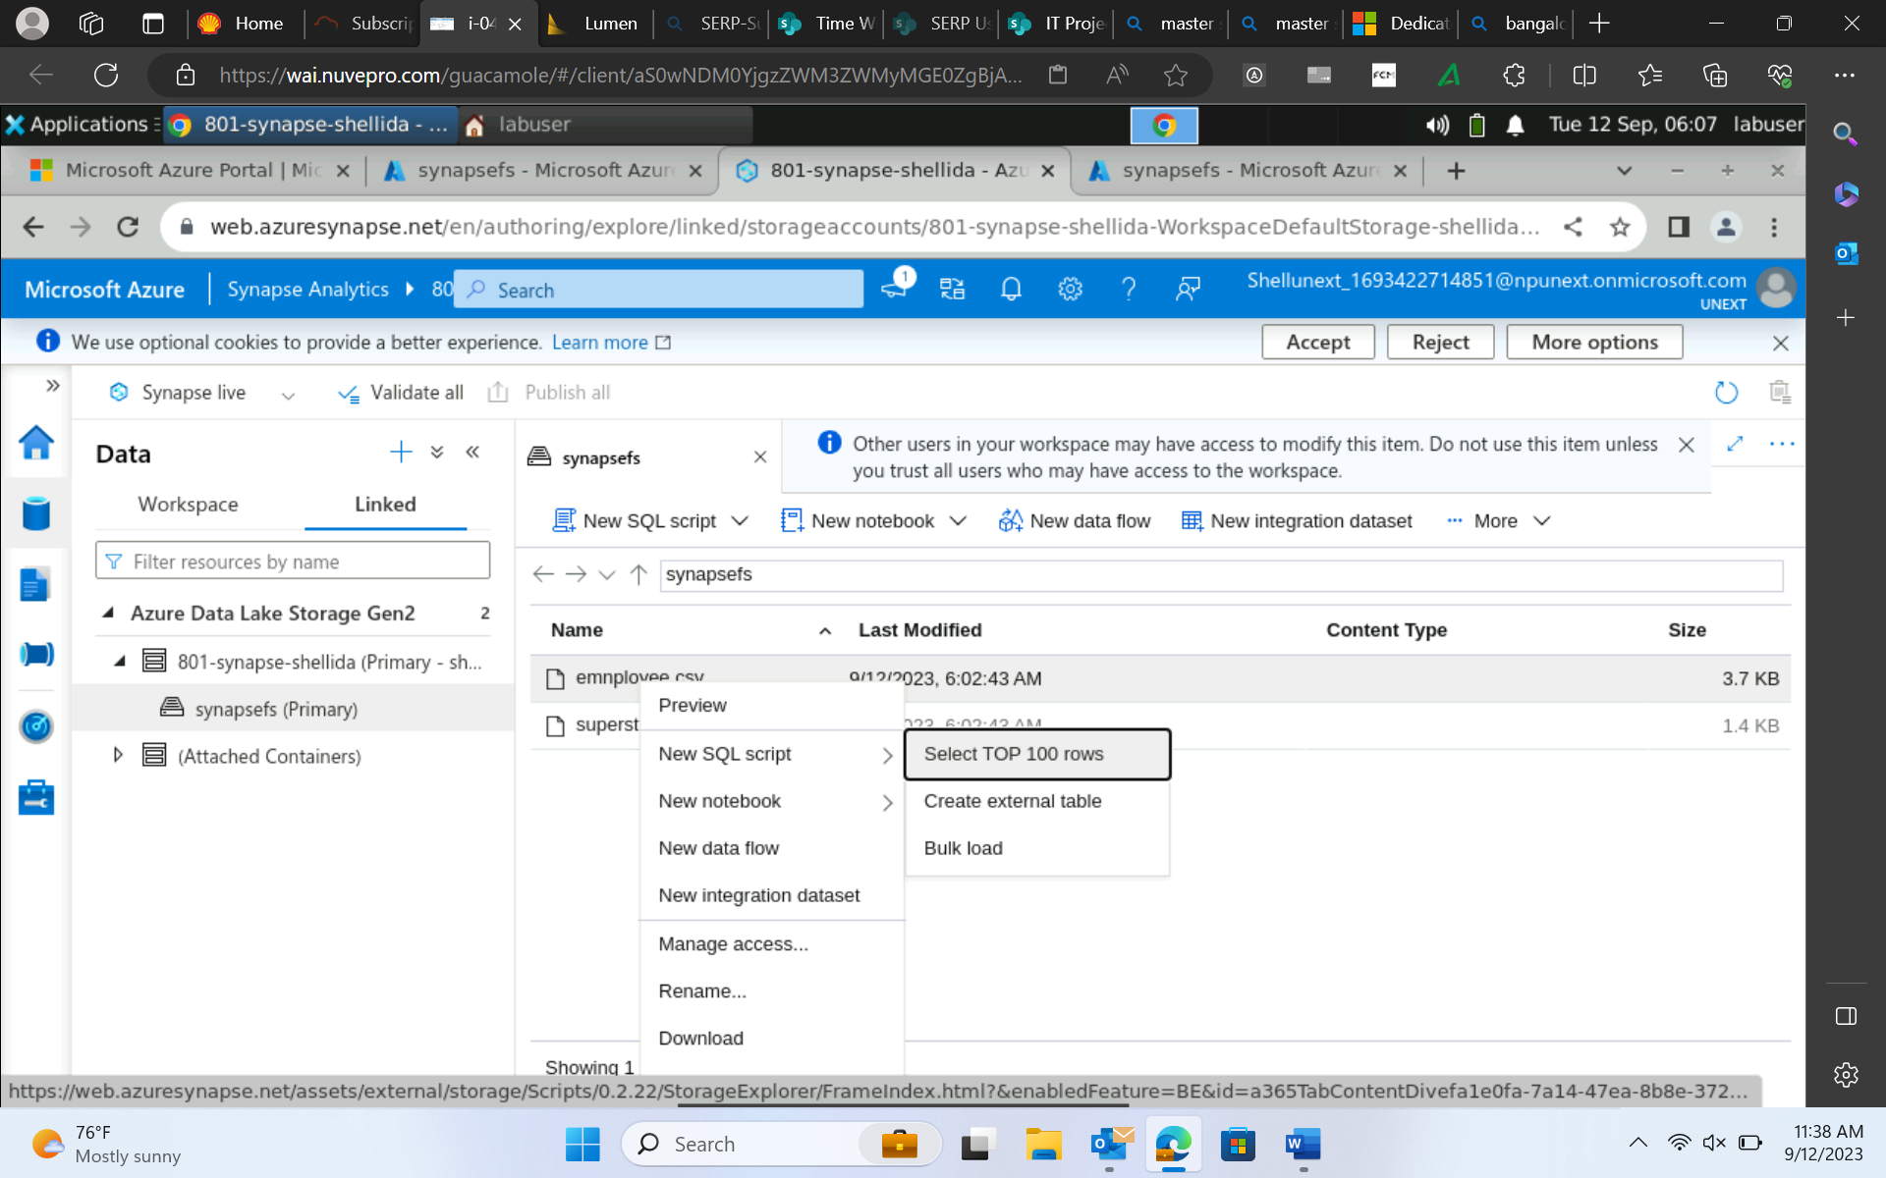

OPENROWSET 🡪 function which creates a view of files in data storage.

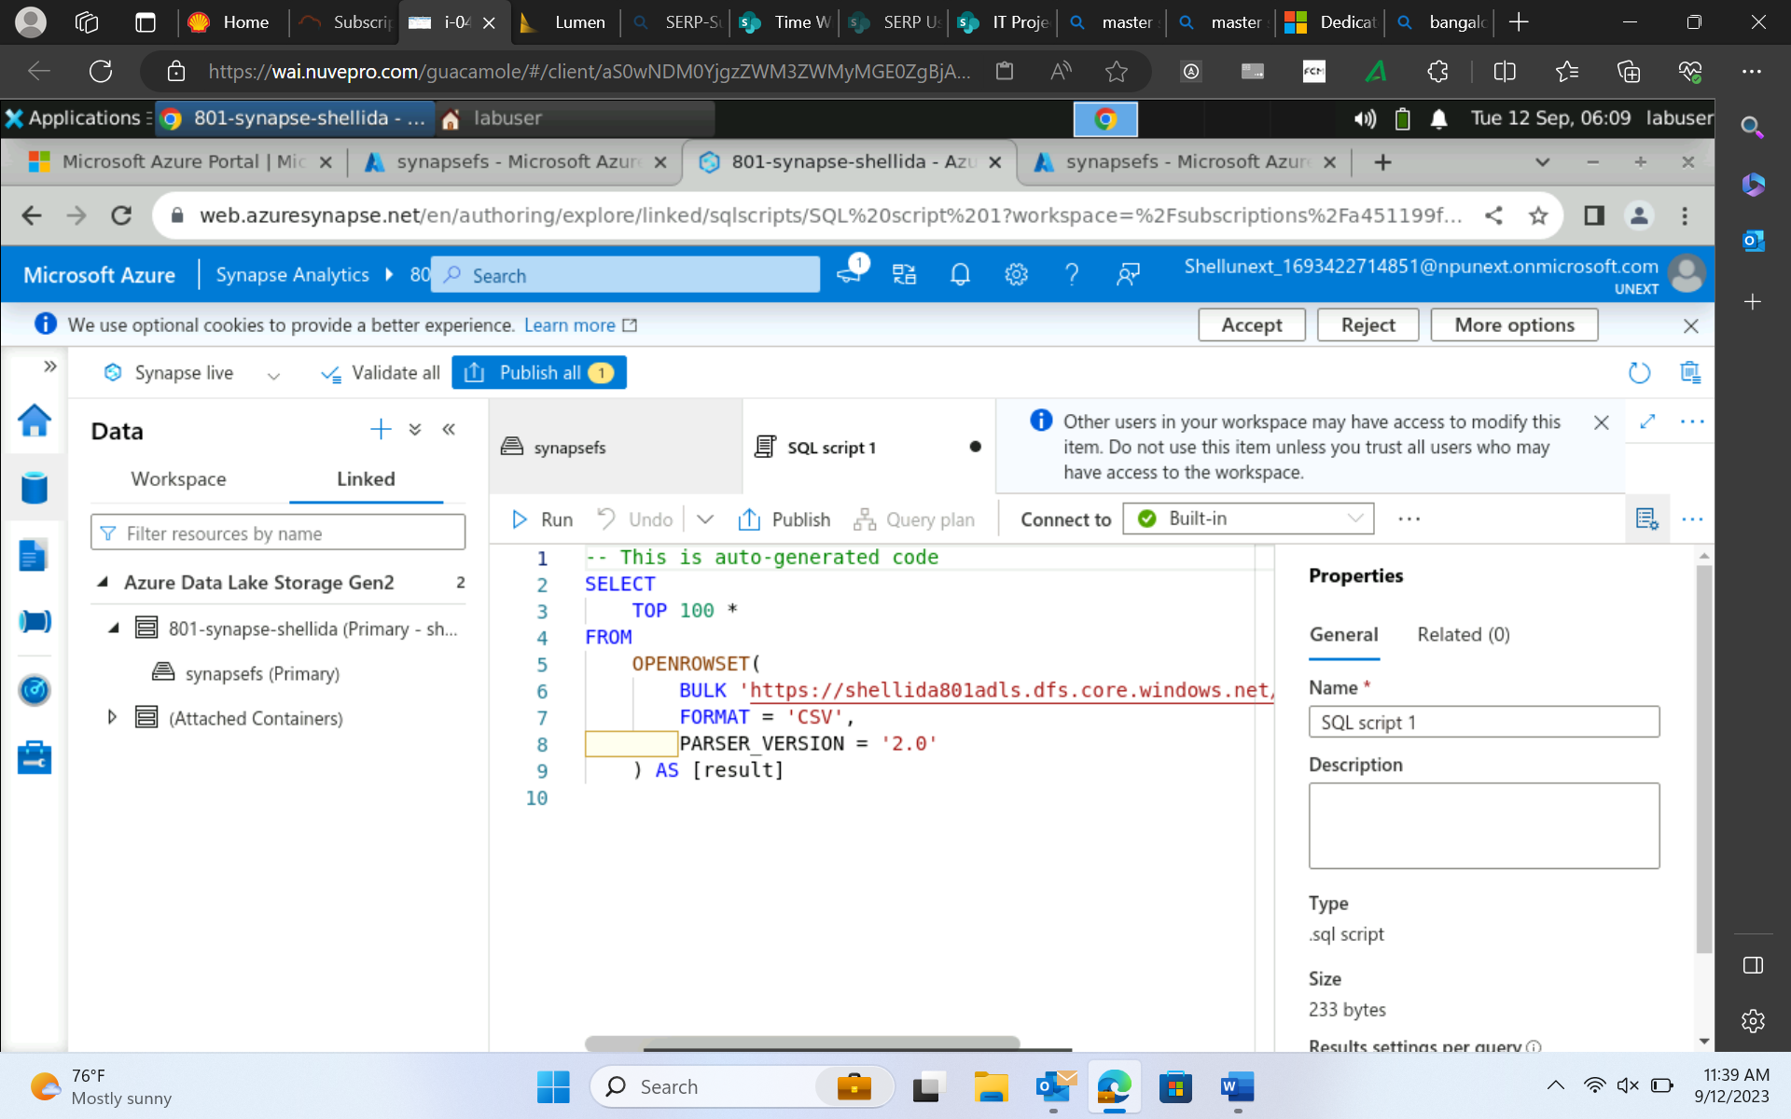

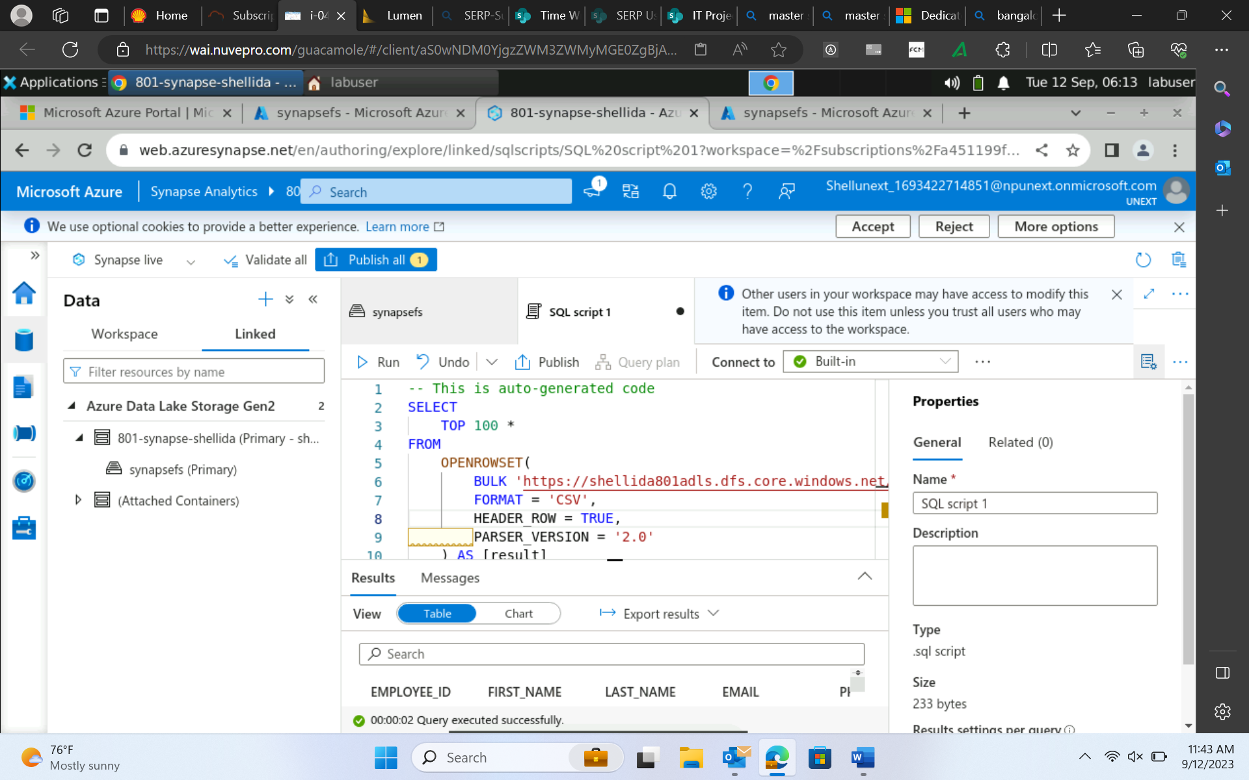

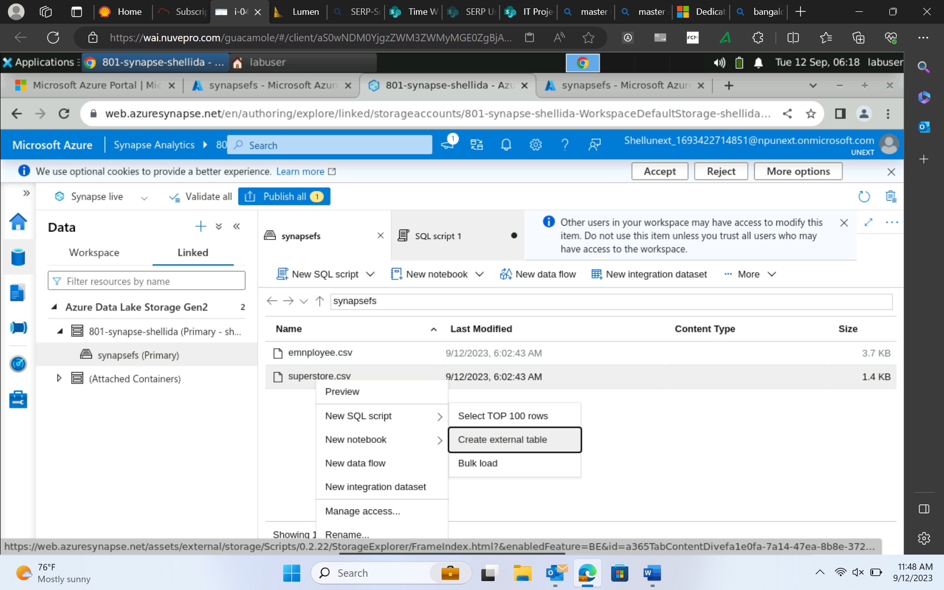

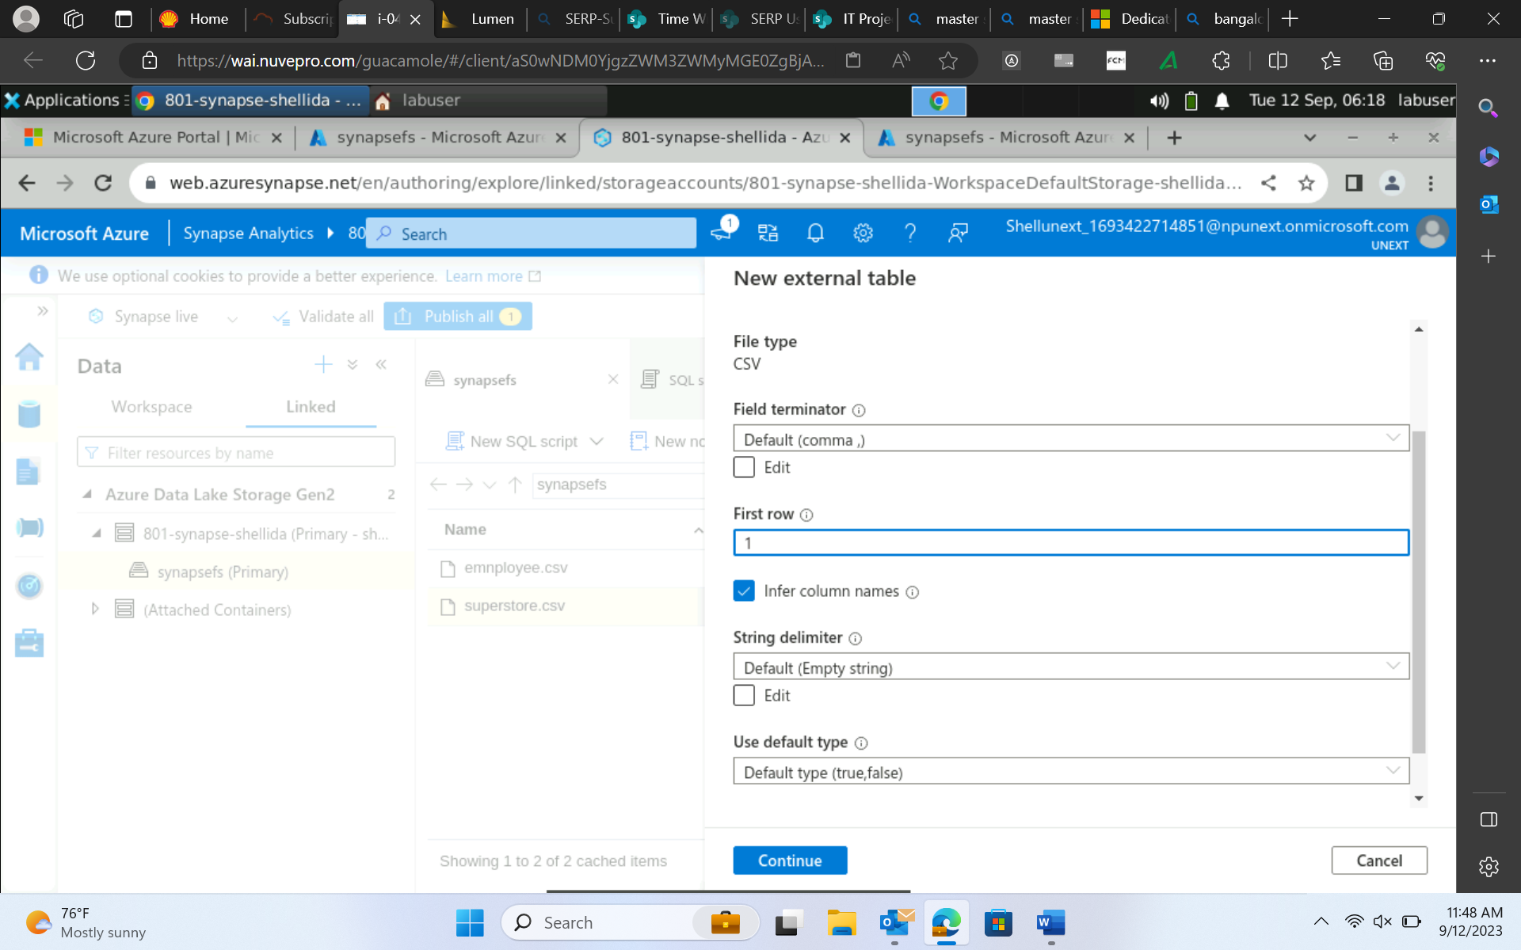

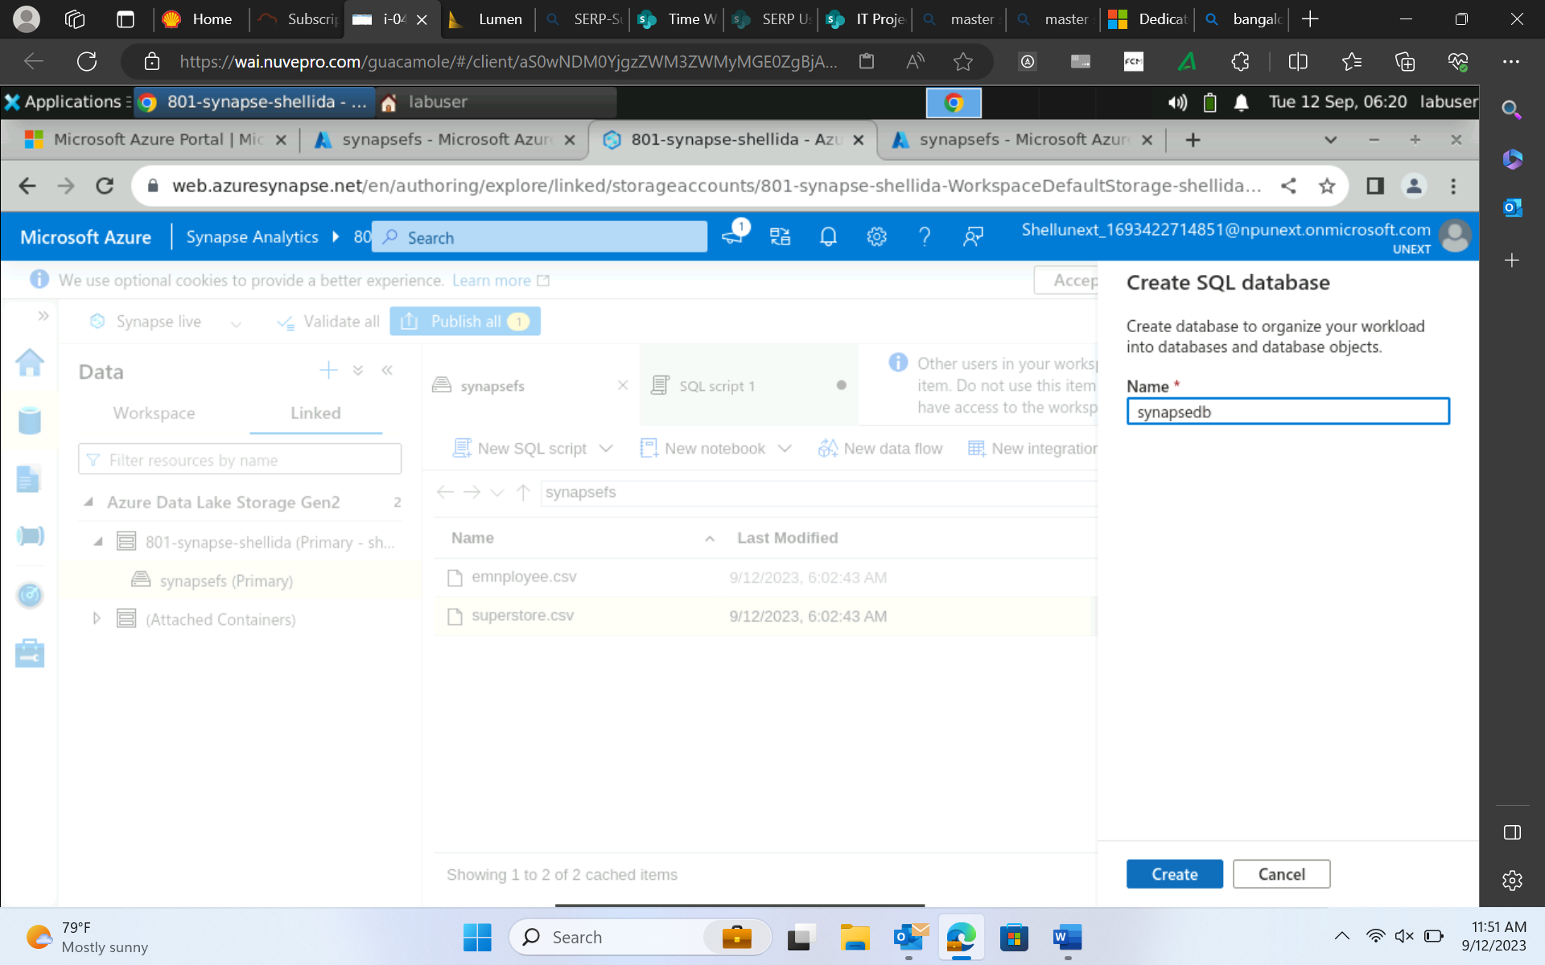

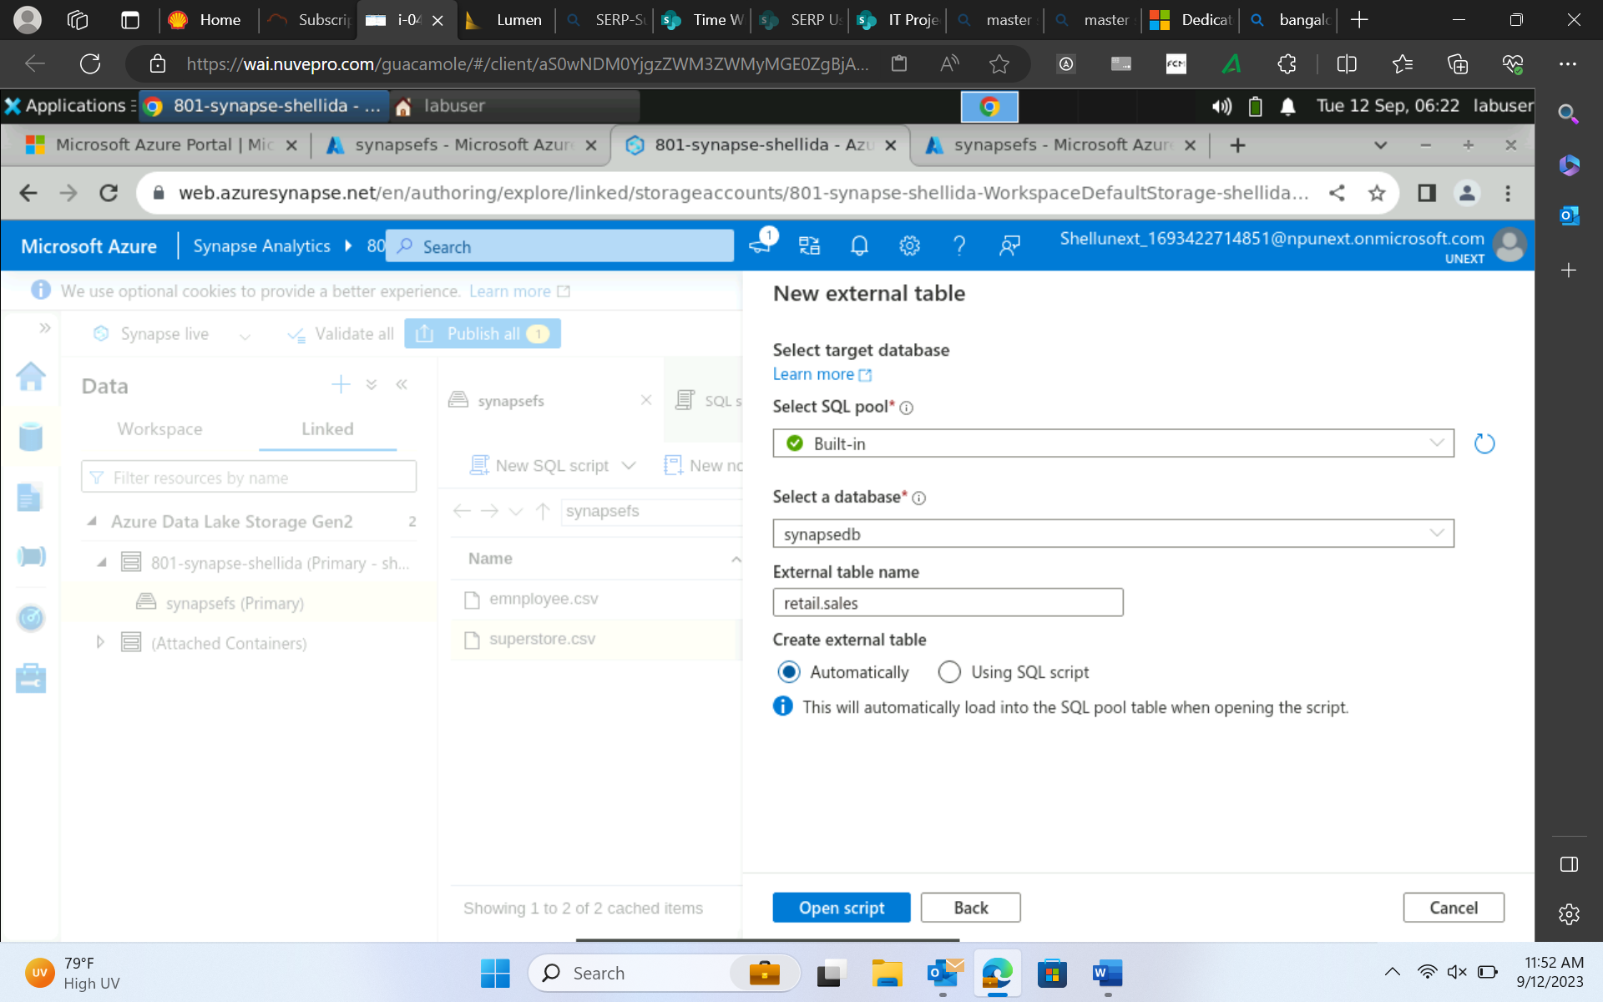

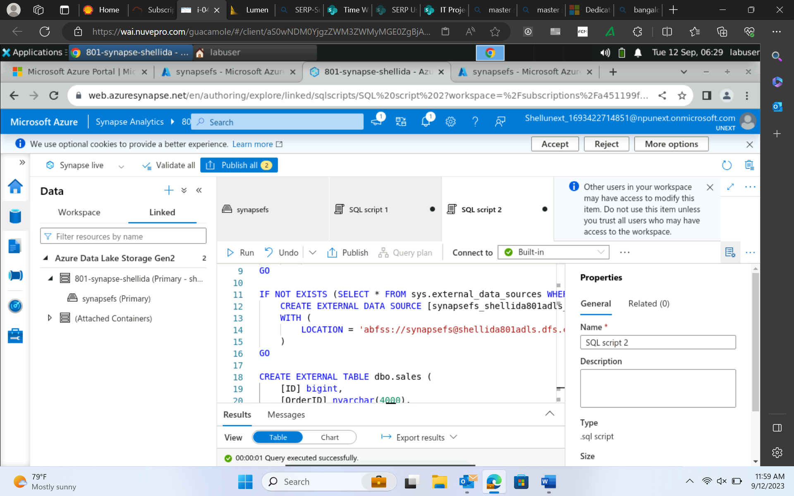

Managed table external table

Drop table sales; both data and metadata deleted only schema gets deleted but data remains same. Read only table 🡪 no DML allowed

Also known as Schema on read;

Truncate tablename

1. How to write sql query on top of file.
2. Create external table on top of file.
3. Create a table and perform bulk load.

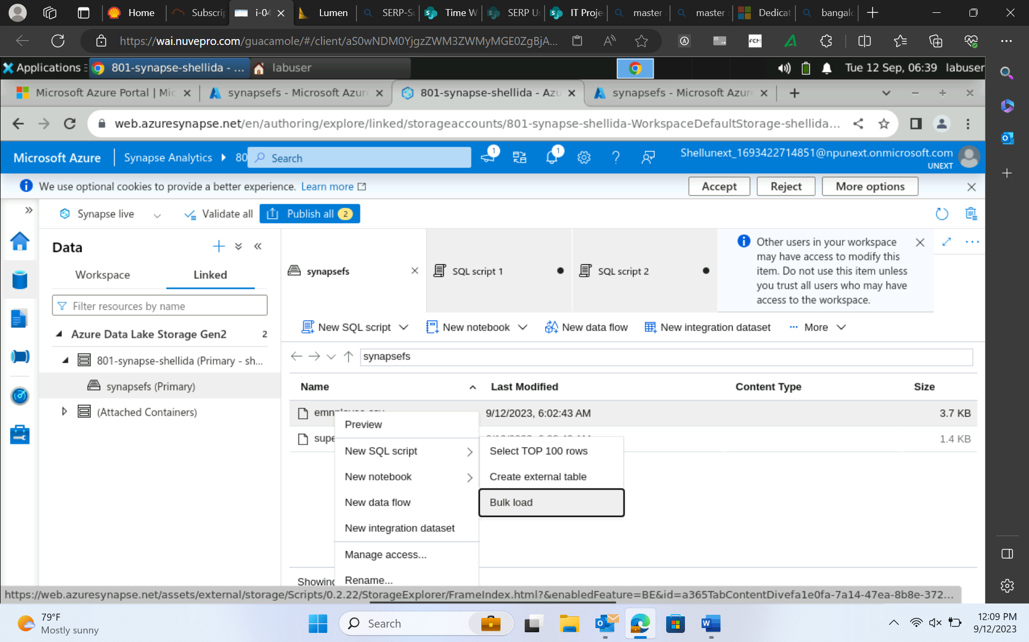

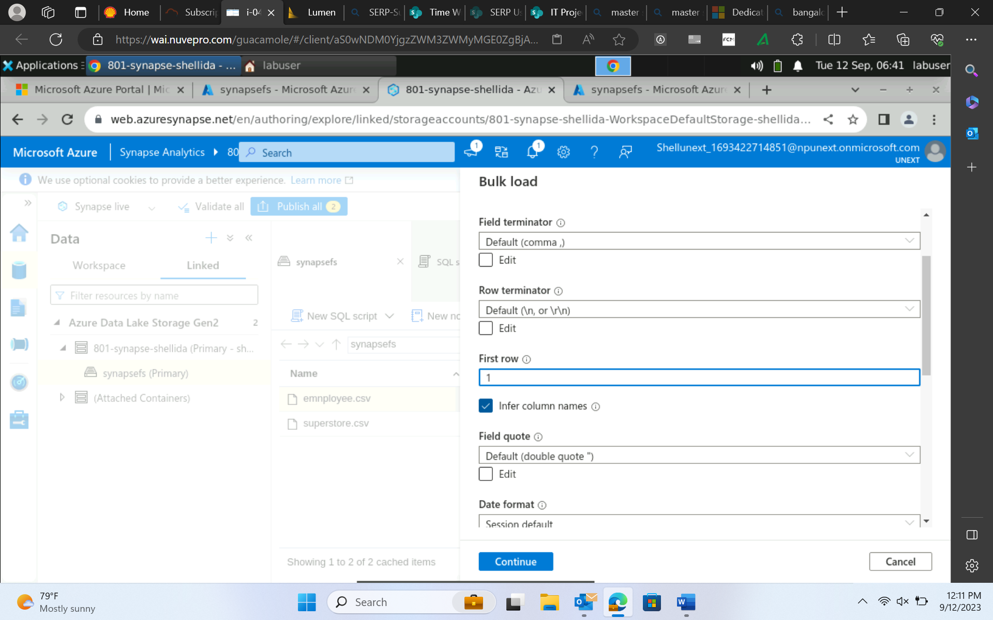

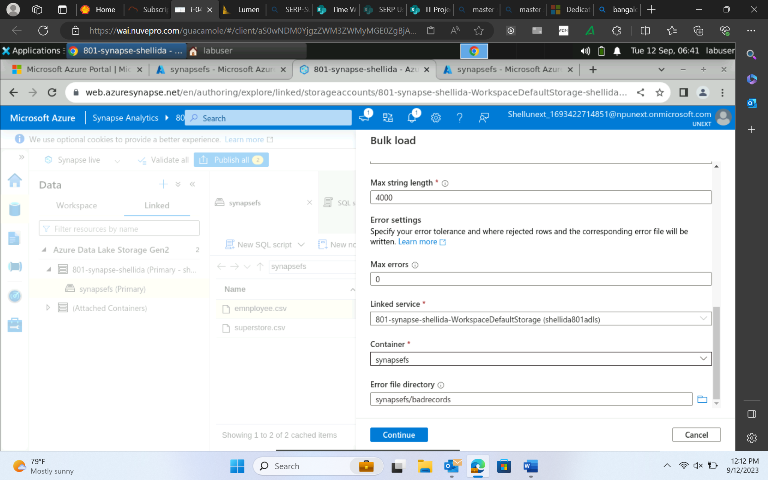

Continue 🡪 manage pools

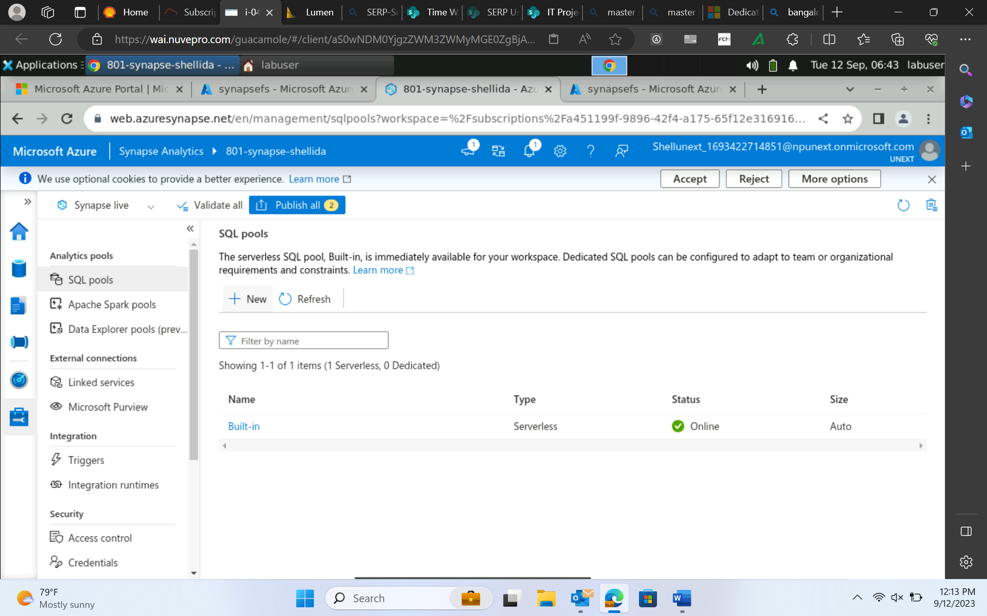

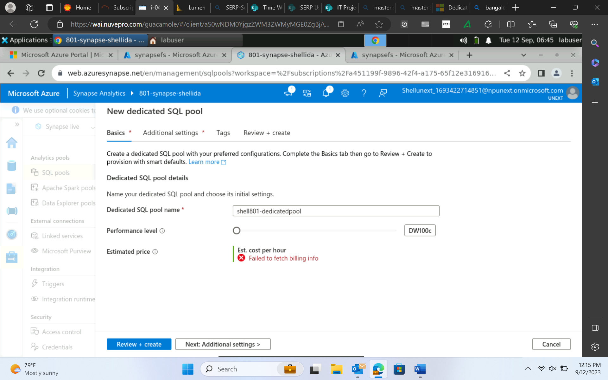

Bulk load 🡪 copy data from src to target table

